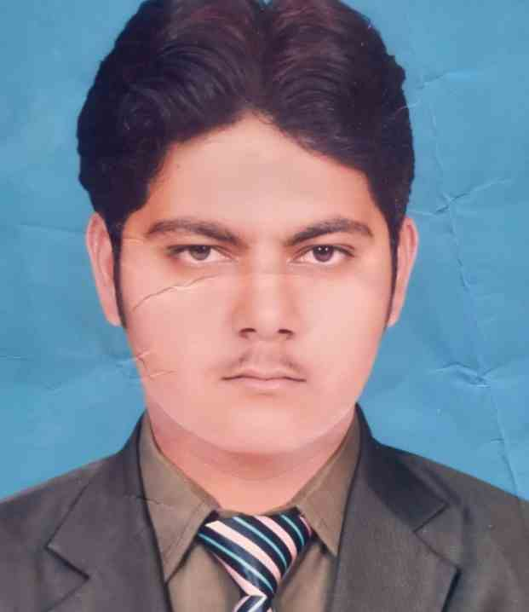

**Curriculum Vitae**

***PERSONAL INFORMATION***

Name Syed Muhammad Waqas Tahir

Father’s Name Tahir Hussain Shah

Date of Birth 27-01-2001

Address Mouza Muhammad Shah,

Tehsil Malsi District Vehari

Contact No **0302-2110914**

NIC. 36602-7620542-3

Email **azizshahg85@gmail.com**

Religion Islam

Nationality Pakistani

Marital Status Single

***ACADEMIC QUALIFICATION***

|  |  |
| --- | --- |
| **Degree** | **From** |
| **MPA (HR)** | **Islamia University Bahawalpur (final semester)** |
| **B.S.C** | **BZU 411/800** |
| **F.S.C** | **Multan Board 604/1100** |
| **Matric** | **Multan Board 872/1100** |

***PROFESSIONAL EDUCATION***

* MS Office, word, excel

#### EXPERIENCE

Two Years’ experience as a science teacher in bright future academy

***OBJECTIVES***

I want to work with well-reputed institution. So I would find the opportunities to make full use of my potential capabilities, polish my skills, gain more professional knowledge and experience and play constructive part on my behalf.

**LANGUAGES**

Fluent in the following languages (both written and spoken)

1. English
2. Urdu
3. Punjabi

***REFERENCE***

Will be furnished on Demand.